**Database** - collection of data that can be easily accessed (Digital).

Software application that is used to manage our DB is called **DBMS.**(Database Management System)

**Types of Databases**:

**Relational databases (RDBMS)** - data is stored in tables. Ex: Mysql, postgresql,oracle.,microsoft SQL server etc

**Non relational database(No SQL)** - data is not stored in tables. Ex: mongoDB

We use **SQL (structured query language)** to interact/work with relational databases.

It is used to perform **CRUD** operations:

Create

Read

Update

Delete

Table is used to store the data in rows and columns in database.

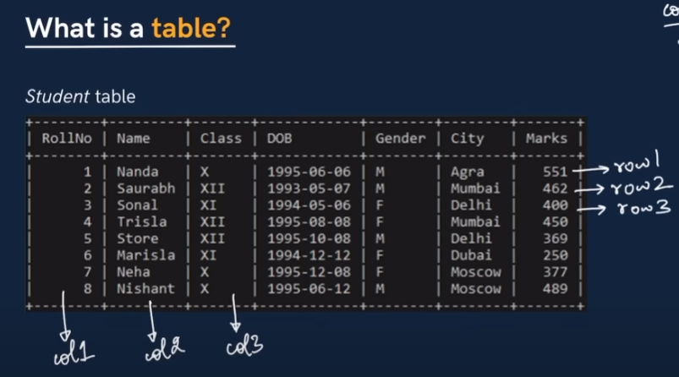

Schema - tells the columns in the database.

**Creating the database**

CREATE DATABASE classroom; - creates the database

DROP DATABASE classroom; - drops the database

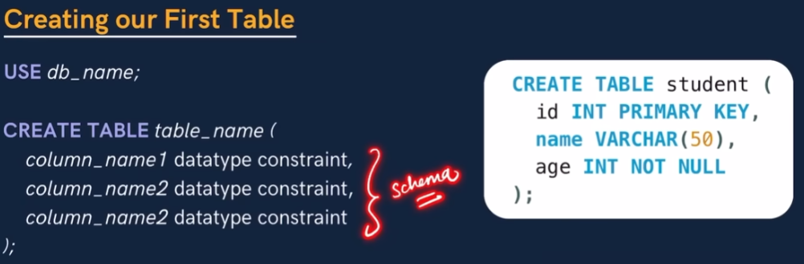

Primary key - always must have unique value to it.

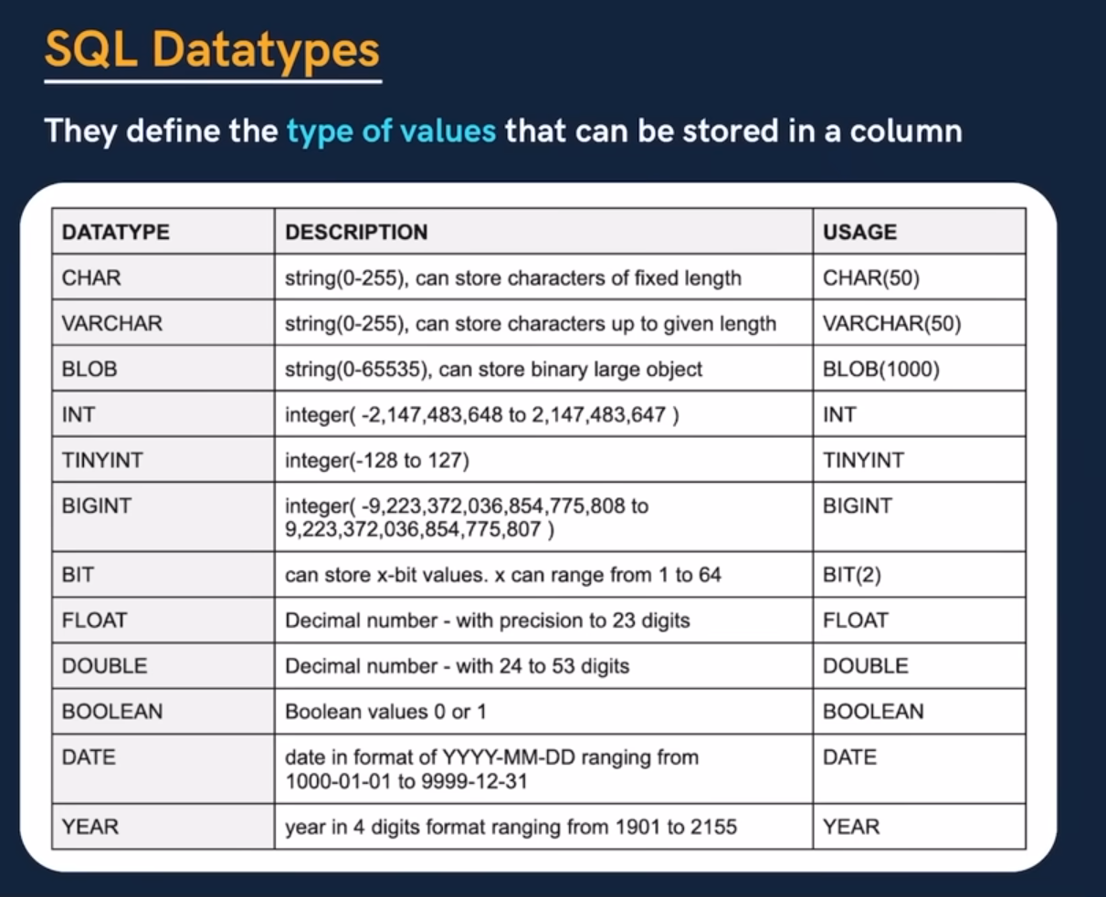

**CHAR** - is used to store strings - a single name or value ex: used to store name, city, country

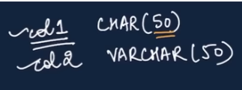

For CHAR datatype - even if the value is lesser that 50, it will reserve all 50 bytes to it.



But in case of VARCHAR, it will allocate only what is needed while defining the value.

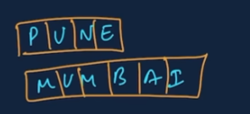

So in VARCHAR no extra memory is wasted.

**Signed datatype** - of the type, int, float etc, where the values can be -ves or +ves.

The variables where we know the values gonna get out of range - we use **unsigned**



All the memory used by -ves go to +ve values if we assigned unsigned

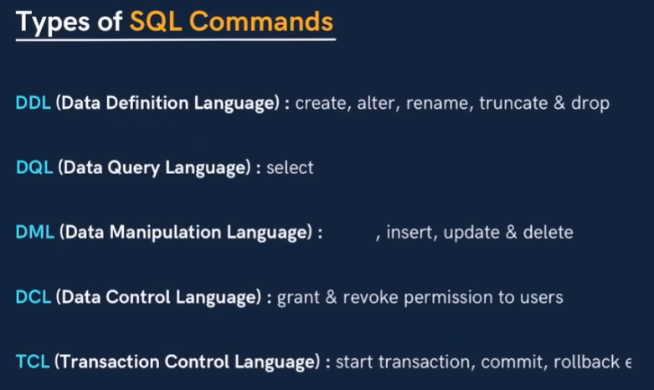

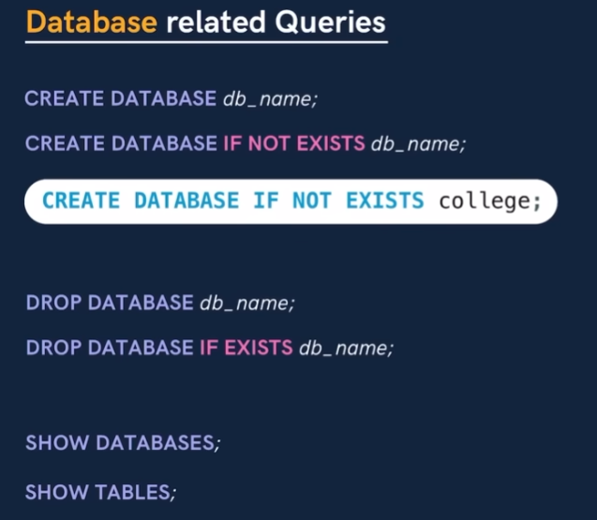

**If not exists** - only creates if the item does not exist.



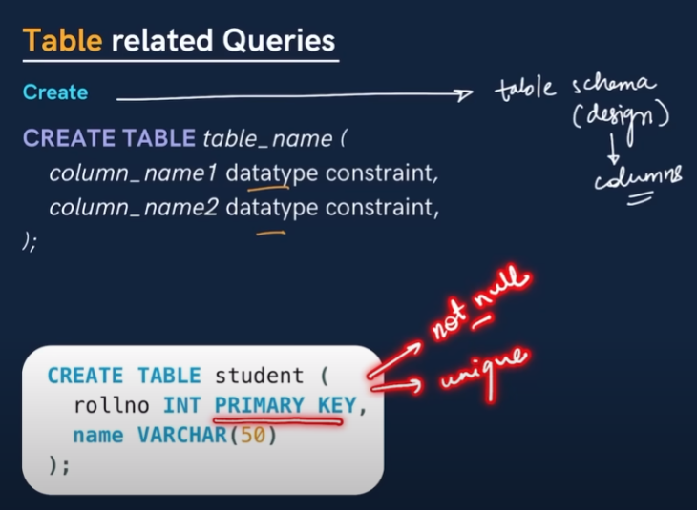

To get all the data from student

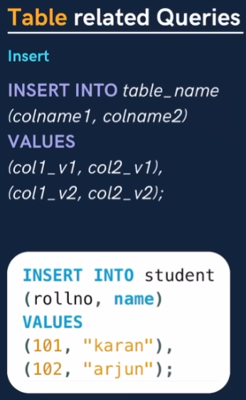 values must be stored in order

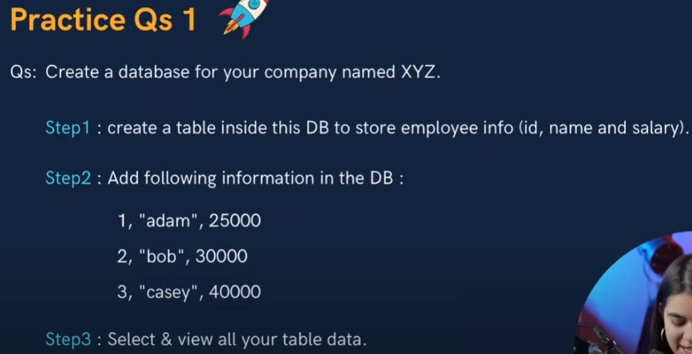

**KEYs**

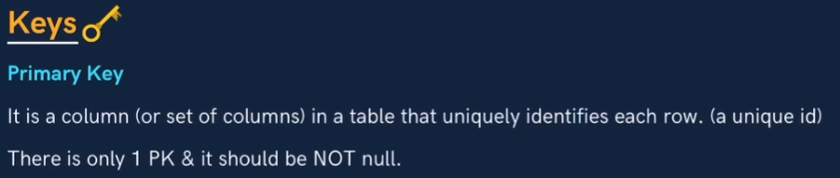

One table can have only one primary key



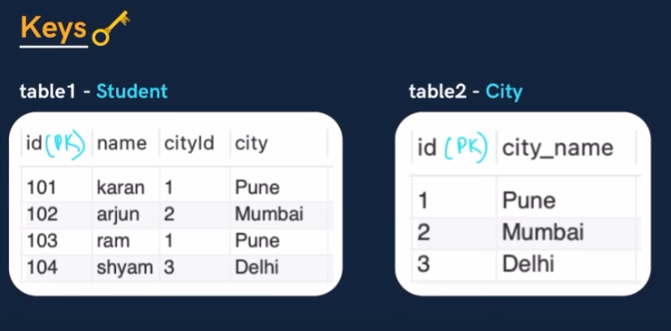

CityId from first table becomes foreign key taken from another table.

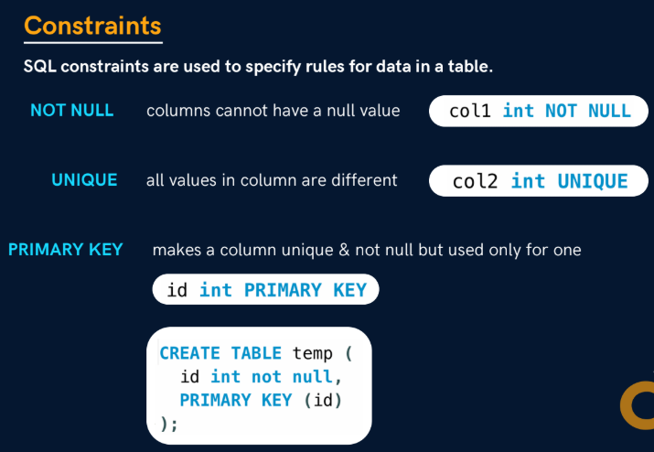

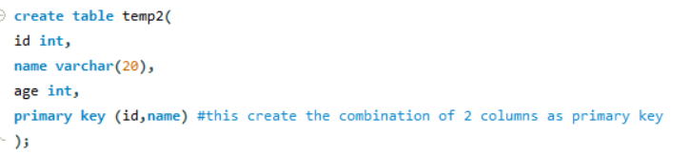

If we define the primary key as combination like this, we can have I=duplicate id or name individually but the combination of them should be unique and not null.

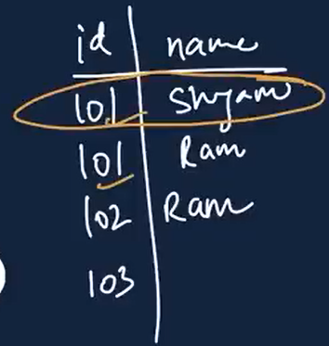

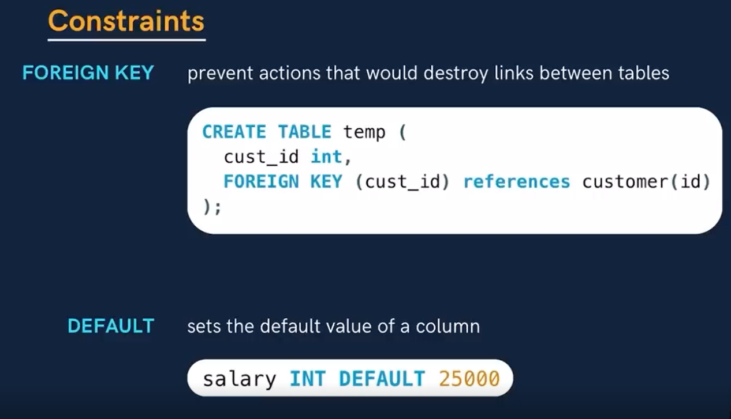

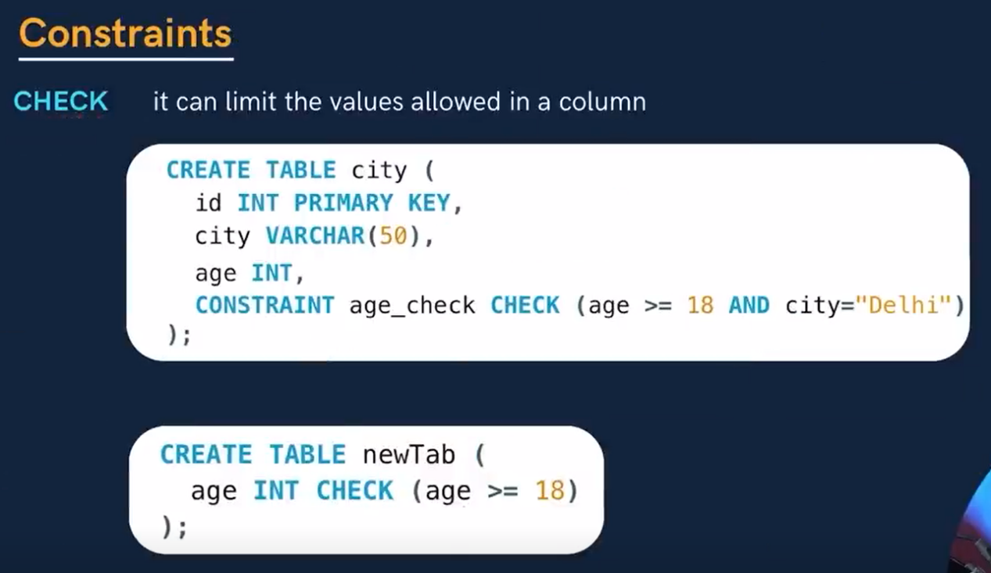

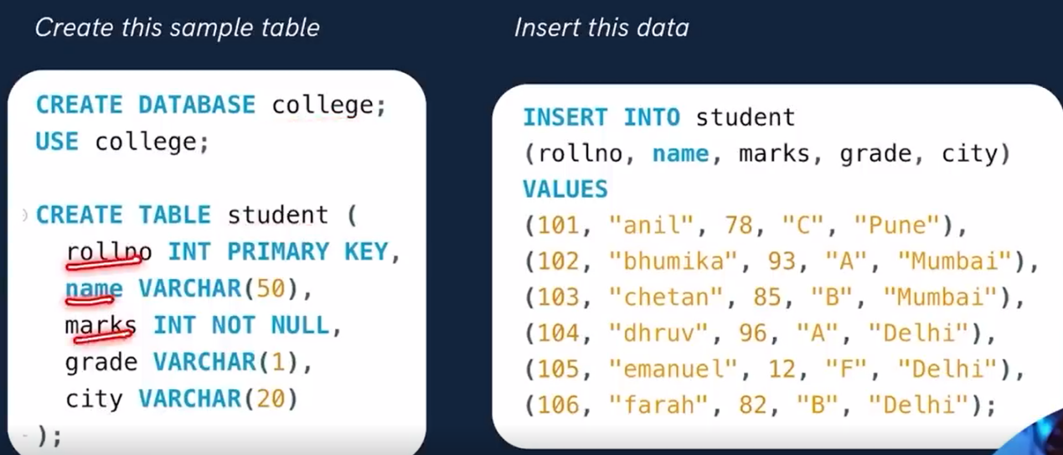

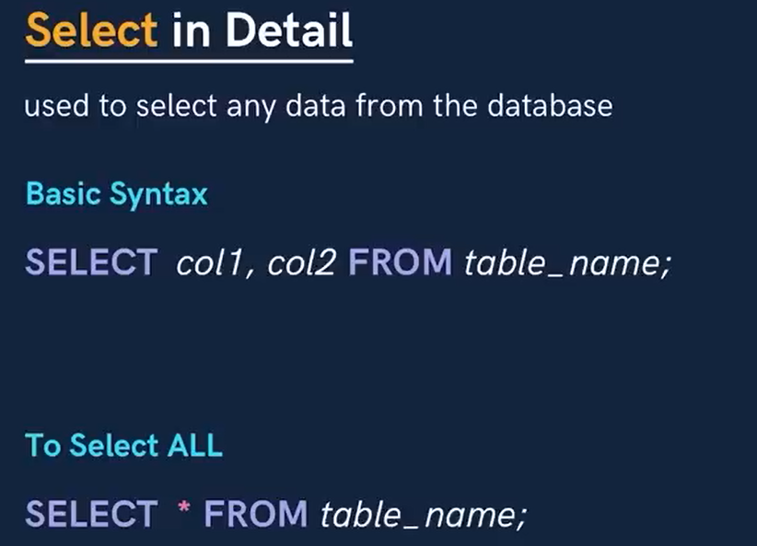

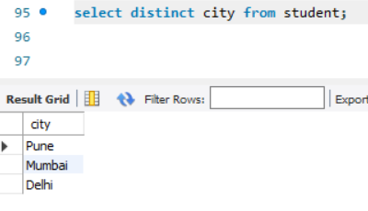

**Distinct** selects unique values from the column selected.

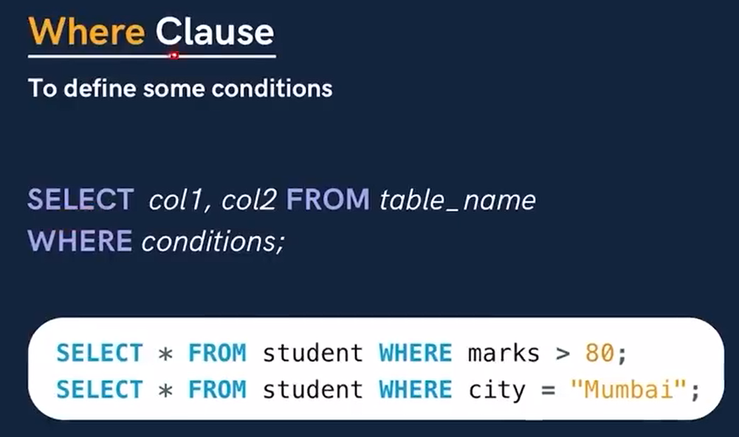

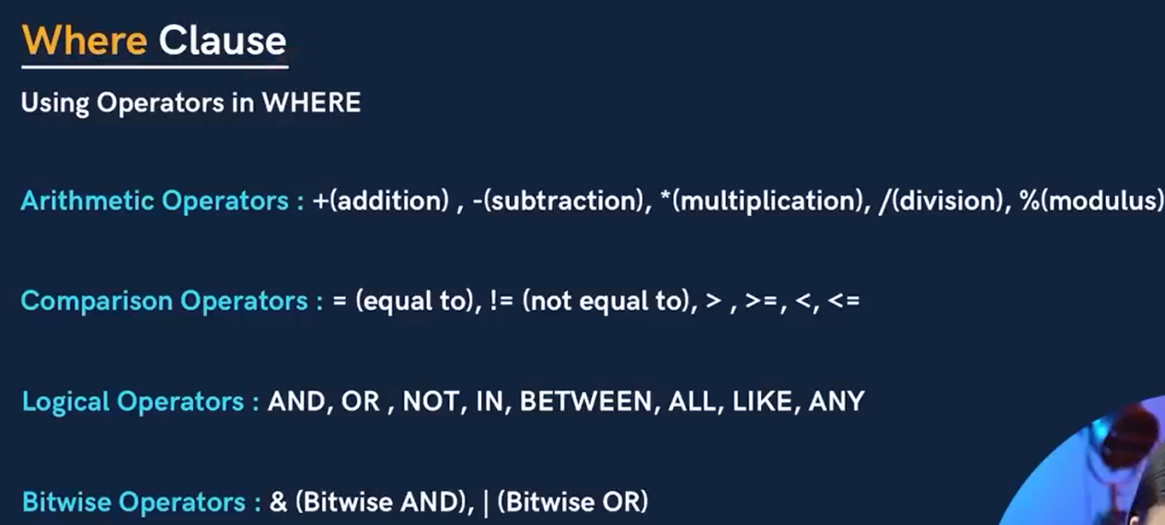

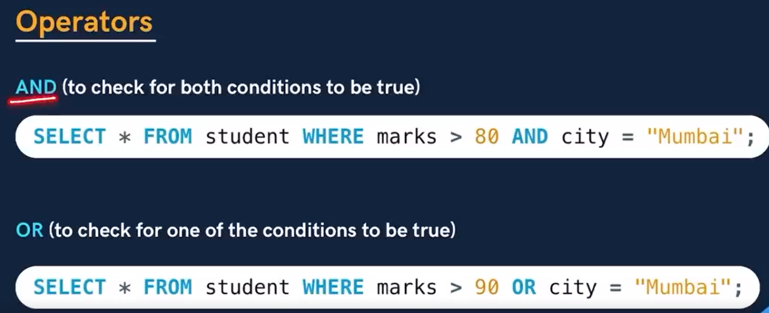

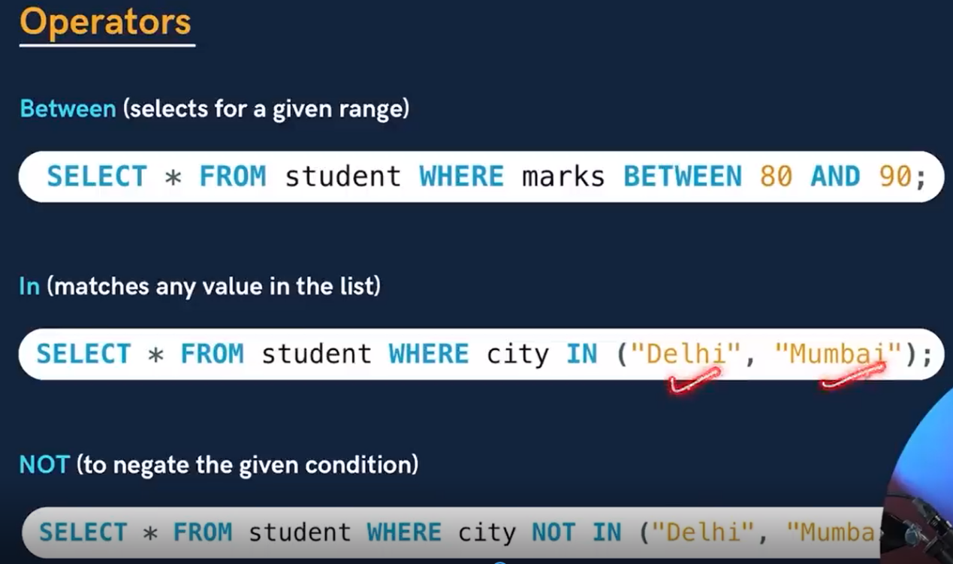

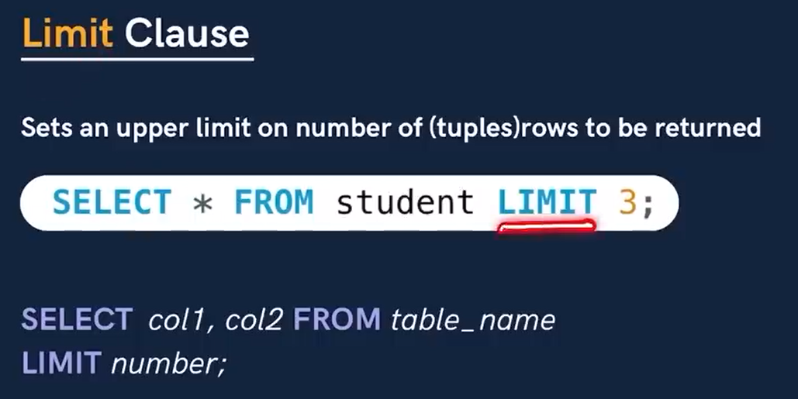

Select * from student where marks > 75 limit 3;

Here it will short list the students among those who have 75 and printing only 3 rows.

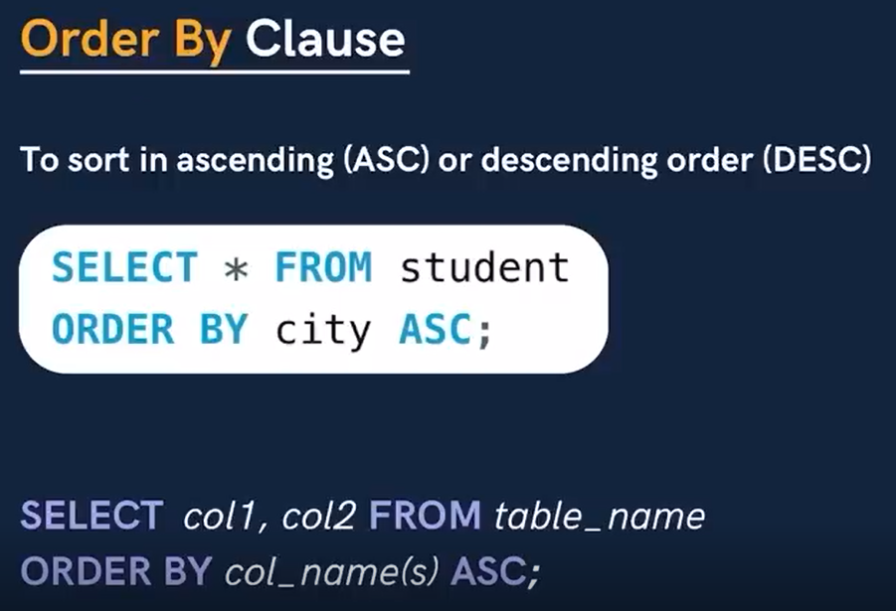

You don’t have to mention if it needs to be in ascending but its imporatnt to mention if you want to order by desc order.



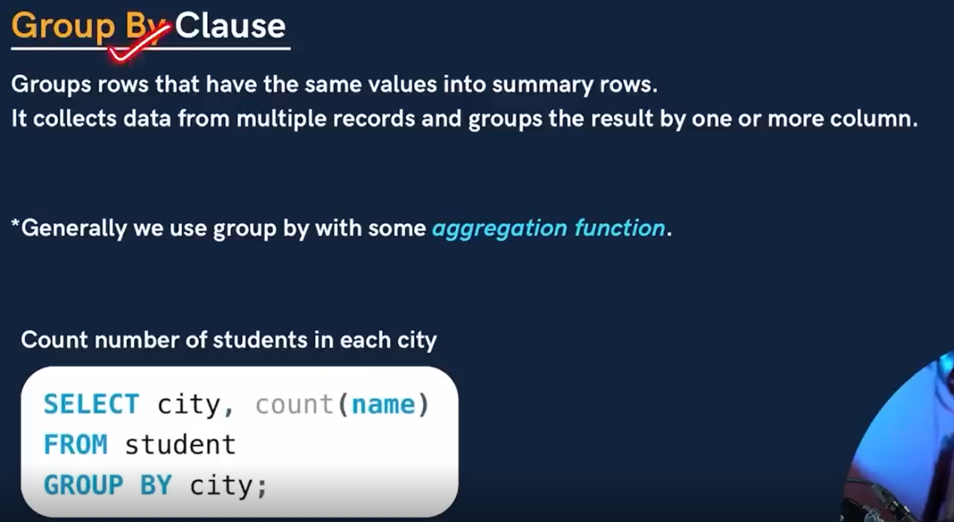

Keep in mind that if you are grouping with city then the select statement must include only city, Otherwise you’ll get an error

Select city,name… group by city,name -> this is the right syntax.

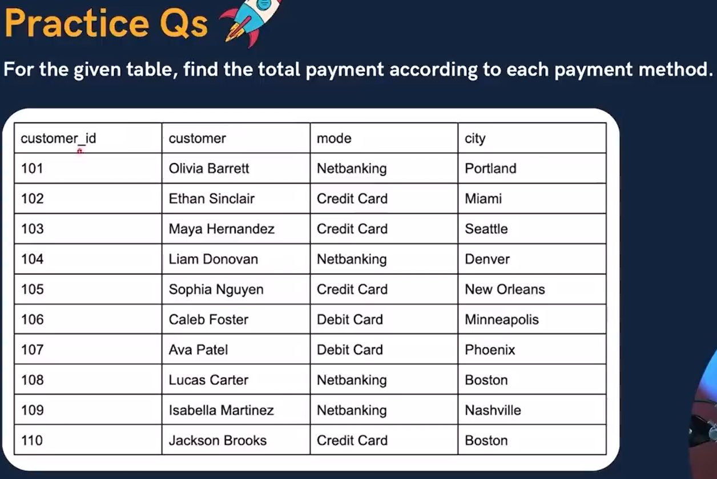

If this table is called payment

Select mode,count(customer_id) from payment group by(mode);

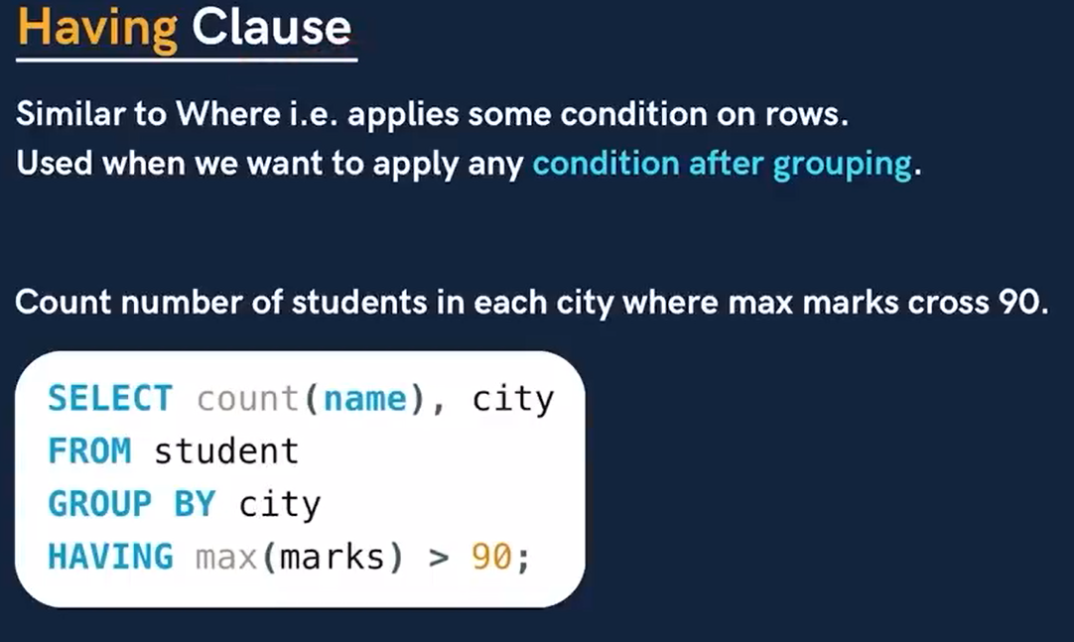

This is used in places where you cannot use where clause.

Especially if you want to apply conditions on groups.

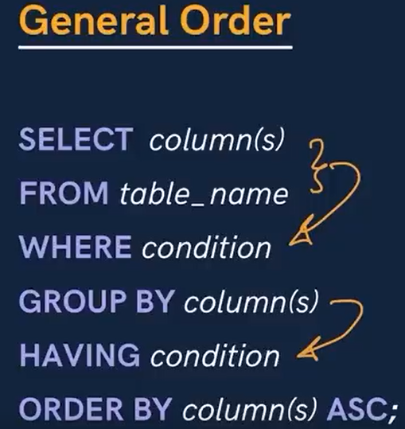

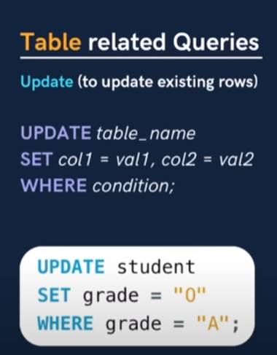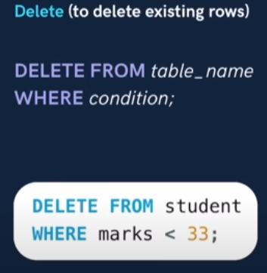

If you get the error 1175 - you entered the safe mode.

**SET SQL_SAFE_UPDATES = 0;**

**Be careful whern using delete operation - as this data will be non recoverable.**

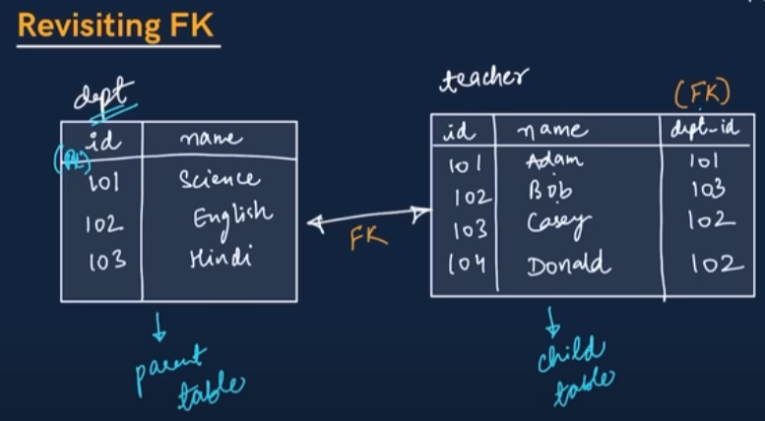

To visualize this in mysql we have reverse engineer option

On the top goto Database -> reverse engineer

Select next and next after that continue select the database that you want to include and execute

Afterwards it creates EER diagram that looks like this (this is for college database)

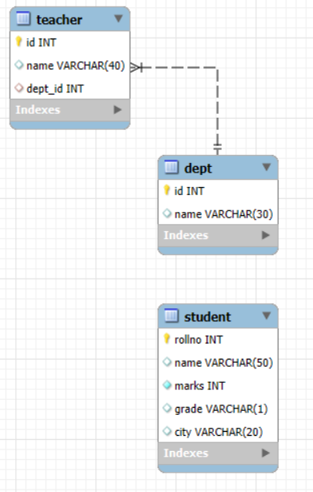

This diagram shows the relationship between various entities in a table.

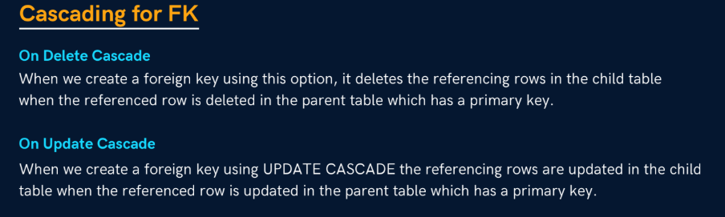

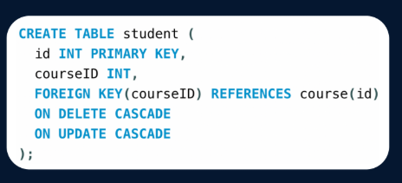

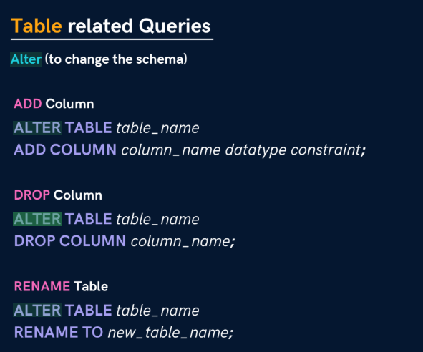

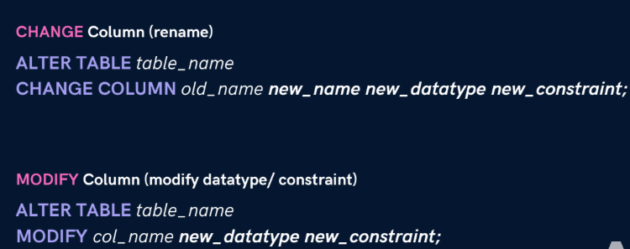

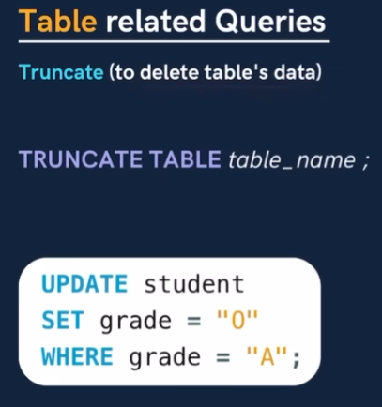

Drop deletes the table, truncate, deletes the data in the table while retaining the table

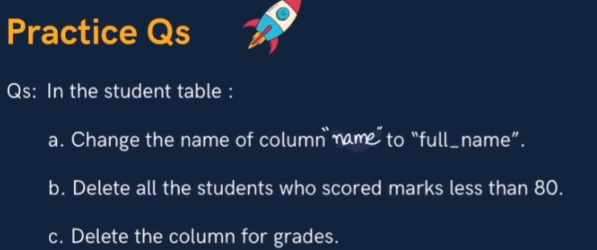



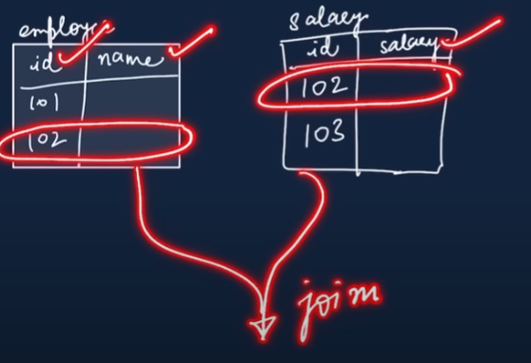 we can only join related columns (foreign key is not compulsory)

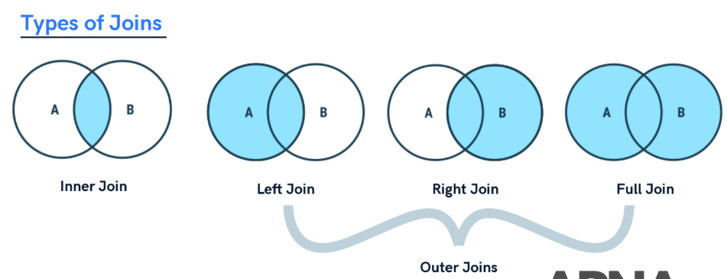

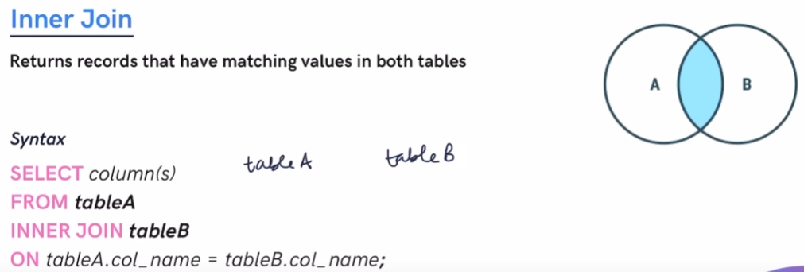

Here is an example,

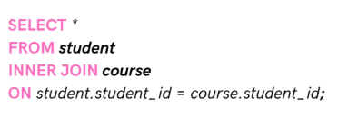

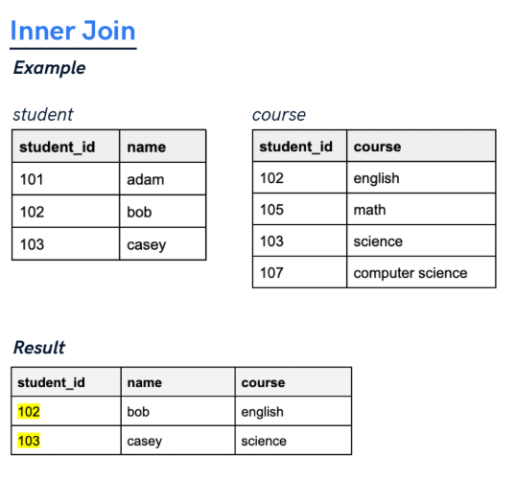

Using alias

Select * from student as s; here s indicates alias of student, going forward we can use s instead of student

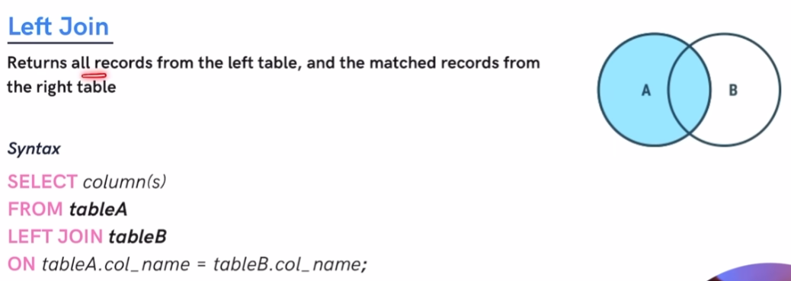

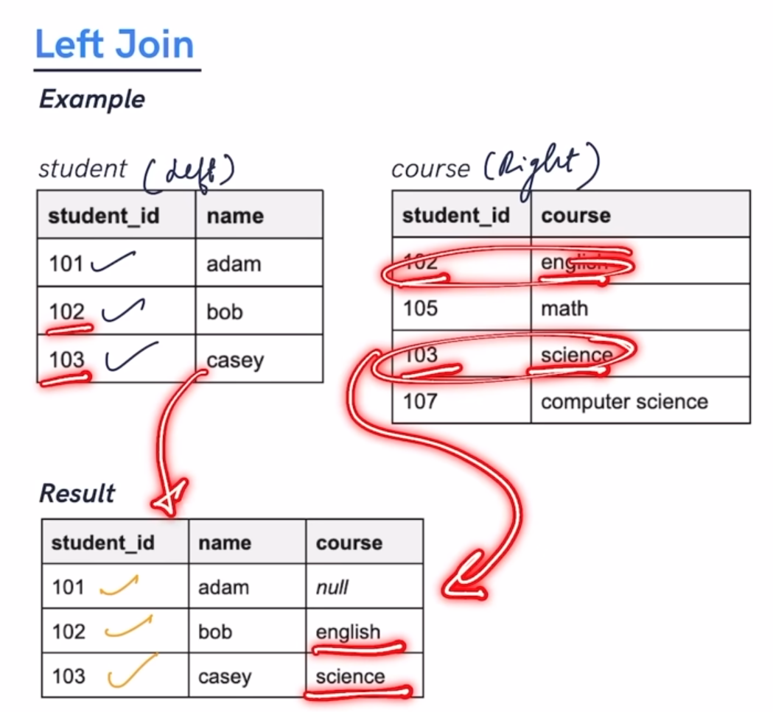

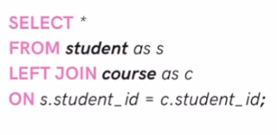

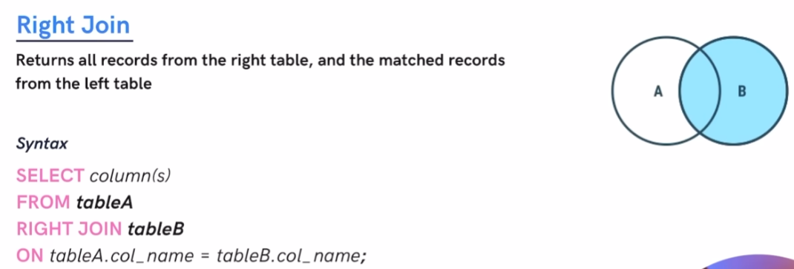

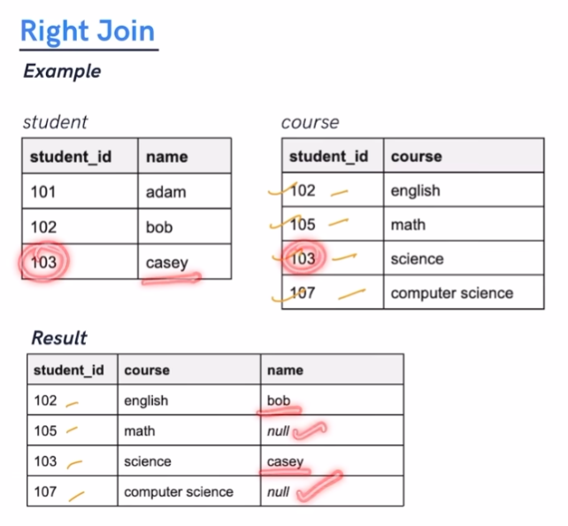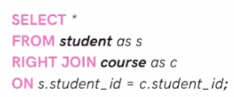

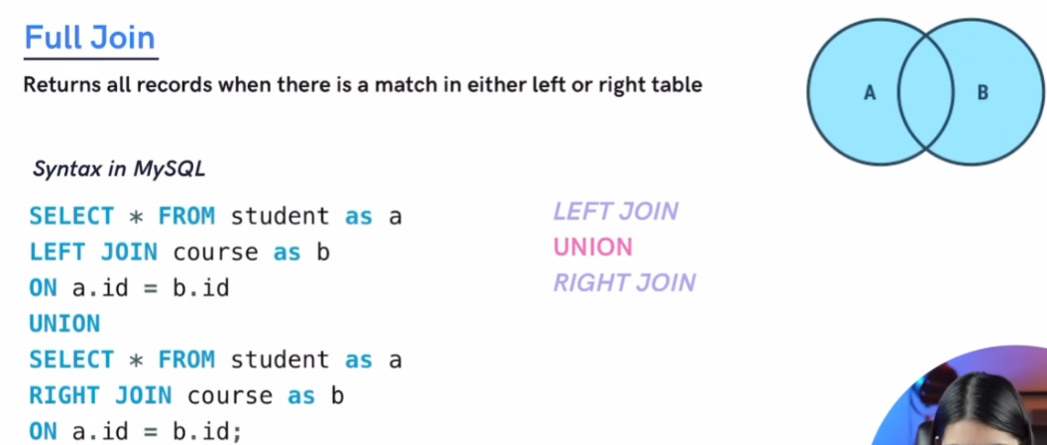

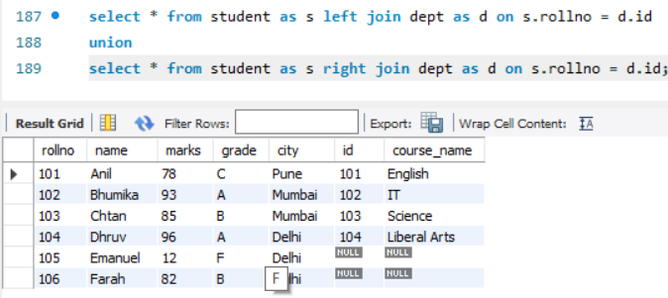

Union - by default gives unique values from the data.

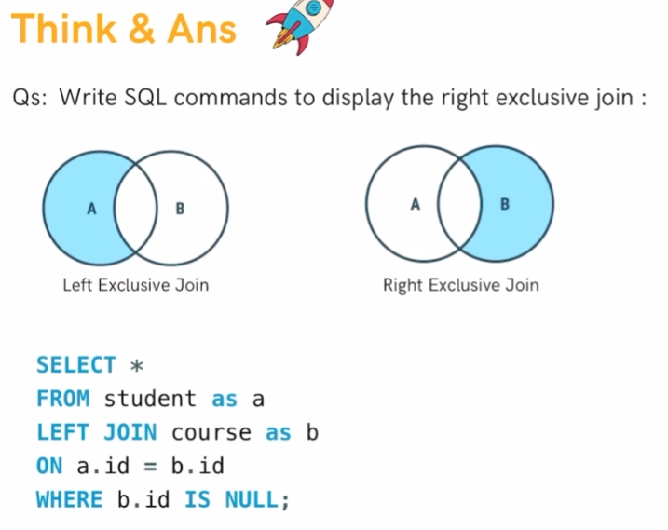

Select * from student as A right join course as B on B.id = A.id where A.id = null;

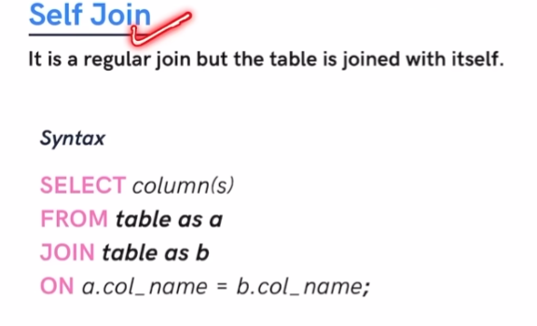

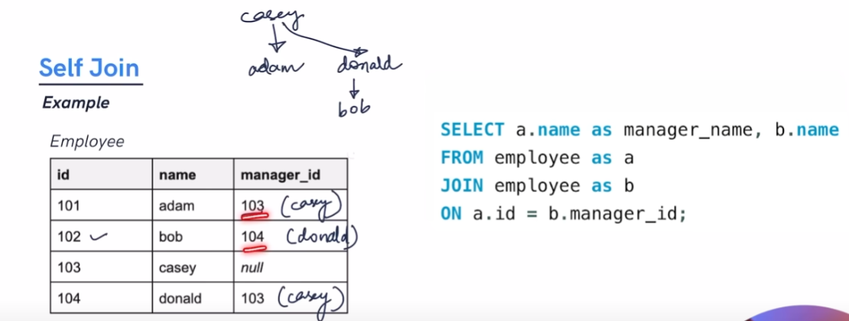

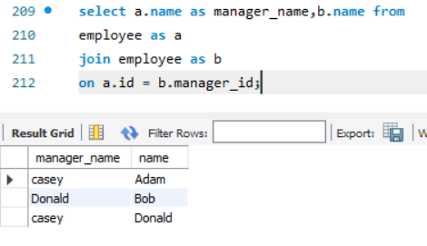

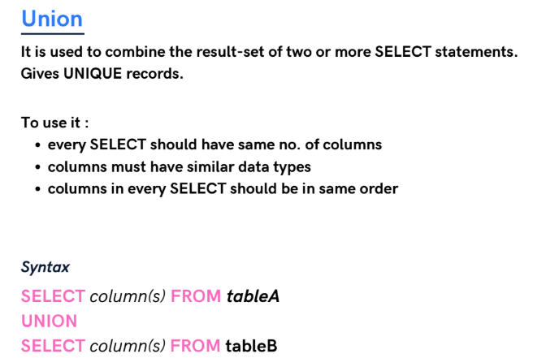

You can use union all to get all duplicates, as it is in both table A and table B

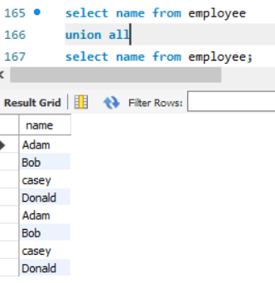

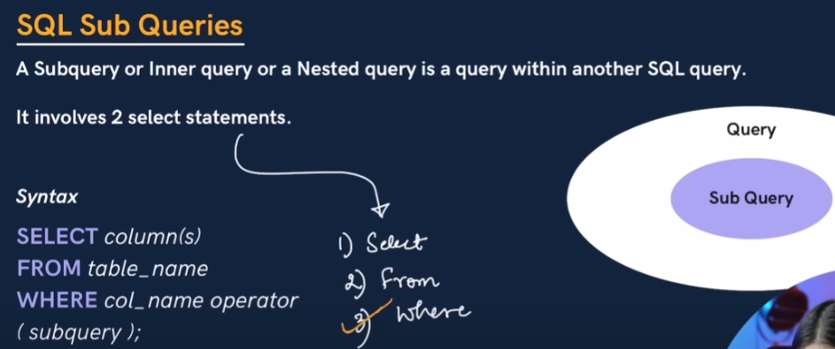

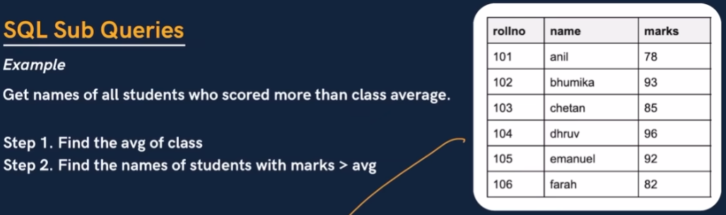

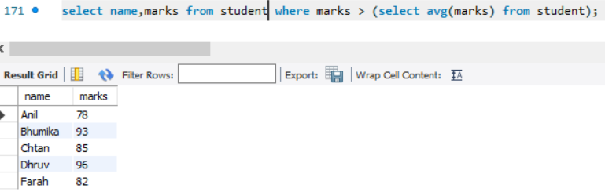

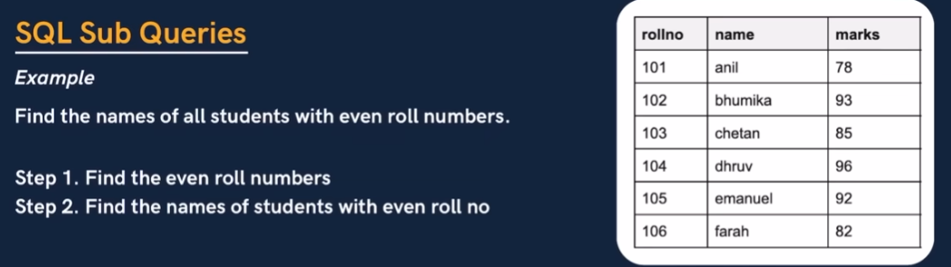

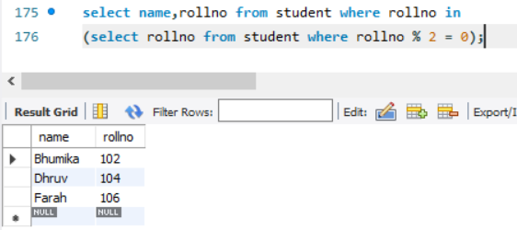

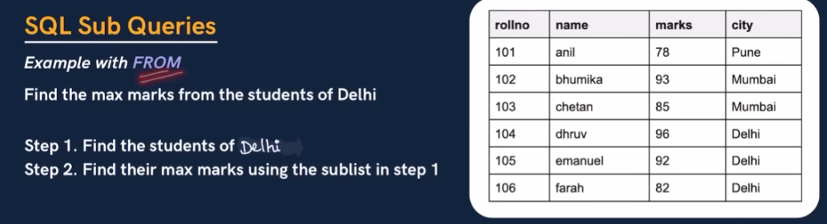

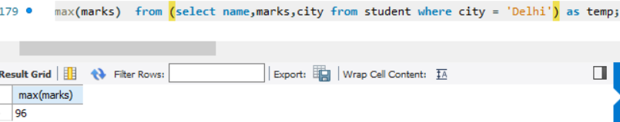

Its very important to use alias when using from clause with subquery;

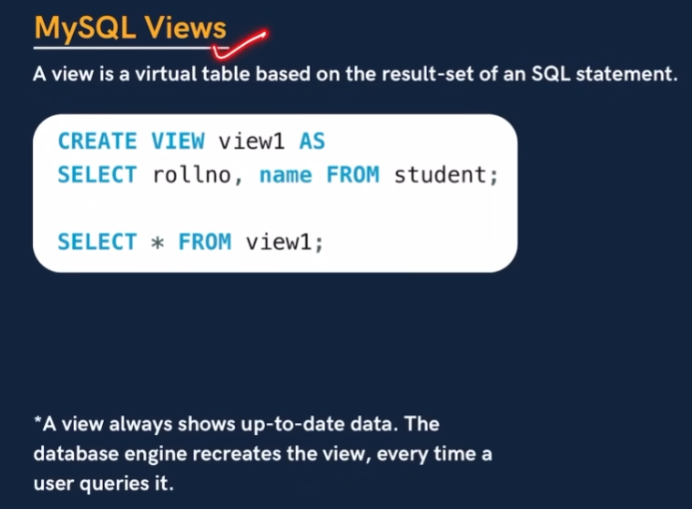

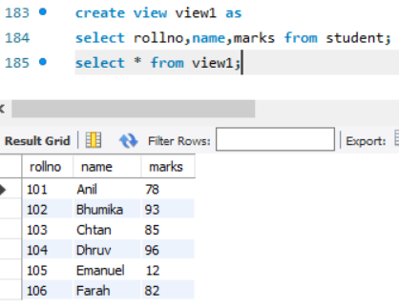

Create virtual table view1.